PROGRAMME SEMI-ANNUAL PROGRESS REPORT
Period: 1 January – 30 June 2018

Project Name | Joint Programme for Sustainable Charcoal Reduction and Alternative Livelihoods (PROSCAL)
Gateway ID | 00100442
Start date | 01 April 2016
Planned end date  (as per last approval) | 31 March 2020
Focal Person | (Name): Abdul Qadir Rafiq
Focal Person | (Email): abdul.qadir@undp.org
Focal Person | (Tel): +254 714 056483
Participating UN entities | FAO, UNDP and UNEP
NDP Pillar | 4- Economic Foundations; 7 – Resilience
UNSF Strategic Priority | Early recovery and rapid return to sustainable development pathways are achieved in post-conflict and post-disaster settings
Location(s) | National
Gender Marker | 2

Total Budget as per ProDoc | USD 6,068,329.00
MPTF: | USD 5,968,329.00
Non-MPTF sources: | PBF:
Non-MPTF sources: | Trac: TRAC: USD 100,000
Non-MPTF sources: | Other:

 | PUNO | Report approved by: | Position/Title | Signature
1. | UNDP | George Conway | Country Director
2. | FAO | Daniele Donati | FAO Representative
3. | UNEP | Juliette Biao Koudenoukpo | Director, Regional Office for Africa
4.
5.

Total MPTF Funds Received |  |  | Total non-MPTF Funds Received
PUNO | Reporting Period | Cumulative | Reporting Period | Cumulative
List Participating Agencies | 1 Jan – 30 Jun | From prog. start date | 1 Jan – 30 Jun | From prog. start date
UNDP | - | 2,680,535 | - | 71,071.71
FAO | - | 1,512,486 | - | -
UNEP | 551,138.79 | 551,138.79 | - | -

 | JP Expenditure of MPTF Funds |  |  |  | JP Expenditure of non-MPTF Funds
 | PUNO | Reporting Period |  | Cumulative | Reporting Period |  | Cumulative
 | List Participating Agencies | 1 Jan – 30 Jun |  | From prog. start date | 1 Jan – 30 Jun |  | From prog. start date
 | UNDP | $ 326, 111.07 |  | $1, 577,953.52 | - |  | 71,071.71
 | FAO | 109,452 |  | 1,131,412.71 | 0 |  | 0
 | UNEP | - |  | - | - |  | -
SEMI-ANNUAL HIGHLIGHTS
- Signing of two letters of Agreements (LOAs) with the Federal Government Ministry of Livestock, Forest, and Range, and Somaliland Ministry of Environment and Rural Development (MoERD) in Q1
- International Conference on Charcoal in Mogadishu for building partnership and curbing Charcoal trade and use
- Procurement and handing over of four Vehicles to the Regional Member States (Galmudug, Hir-Shabelle, South West and Jubaland) Ministries of Environments for mobility and coordination of the full-scale project activities in Q2
- Handing over of 300 fuel efficient cooking stoves with 2 tons of biomass briquettes for Mogadishu IDPs, and 600 LPG Systems as an alternative energy solution for Charcoal in Q2
- Awareness campaign on charcoal reduction and messaging on diversified alternative energy options by Somali artisan, and training of thirty (30) local manufacturers on improved cooking stoves in Q2
HIGHLIGHTS OF KEY ACHIEVEMENTS
As part of the capacity building and awareness raising initiatives, letters of Agreements were signed with the Federal Ministry of Livestock, Forest and Range (MoLFR) and Somaliland Ministry of Environments. Also, Somali artists were engaged to promote extensive awareness raising events on the reduction of the domestic charcoal use and trade through the local media, TVs, and Radios. More than 30 local manufacturers (women:5) were trained on fuel efficient making in Somaliland by the Environment Ministry and rural developments.
To support the implementation and coordination of the full-scale Joint Programme on Charcoal, four vehicles were procured and handed over to the Regional Member States (Galmudug, Hir-Shabelle, South West and Jubaland).
For the alternative solutions to Charcoal reduction, six-hundred (600) Liquified Petroleum Gas (LPG), three-hundred (300) fuel efficient cooking stoves, and two (2) tons of Biomass Briquettes were handed over to the Federal Ministry of Humanitarian Affairs, and Disaster Management (MoHADM), and Federal Ministry of Livestock, Forest, and Range (MoLFR), to distribute to the most vulnerable IDPs in Mogadishu, host community and women retailers respectively. On May 2018, an International summit on charcoal was convened in Mogadishu. Over 350 experts from the Federal Government of Somalia, National Universities, Private Sectors, Somali Diaspora, Gulf Countries, Sudan, Ethiopia, Uganda, Kenya, UN Agencies, INGOs, and Development partners attended whilst unified roadmap to curb charcoal trade was agreed and finalised. To build alliances, Somalia Partnership forum would be held in Brussels in July 2018.
The Peer review for the Draft National and Regional Policy for charcoal reduction has been finalised by the Federal Government. UNEP and UNDP supported the process and the Policy will be presented to the Federal Council of Ministers for approval and ratification. The Policy Programme streamlines strategies and frameworks to minimise domestic use of charcoal and regional trade, and outlines effective monitoring and enforcement of the charcoal trade ban
SITUATION UPDATE
Though overwhelmed by political, and security tensions, Somalia continues to make considerable progress in conflict resolution, inclusive politics, financial reform, job creation and reform in the security sector. Also, Somalia is building alliance with its African neighbours, Gulf Countries, and other International Community to promote developmental progress and prosperity.
With support from the UN Agencies, and other Development Partners, the Federal Government launched Post Disaster Needs Assessment and Resilience Framework (DINA) as first step towards long term recovery and risk reduction. The outcomes of the needs assessment were used to develop a Recovery and Resilience Framework, whose guiding principles will enable the Federal Government of Somalia and the country’s Federal Member States to develop medium- and long-term solutions to the root causes of Somalia’s vulnerability to drought. The launch also featured the 2018 Humanitarian Response Plan that seeks to raise $1.5 billion to address the needs of 5.4 million people nationwide
During the reporting period, no additional funds were received for the Joint Programme on Charcoal and 2018 AWP was revisited and aligned with available budget. New letters of agreements were signed with the federal Ministry of Livestock, Forest, and Range (MoLFR) and Somaliland Ministry of Environment and Rural Development (MoERD).
In May 2018, the International Summit for building an alliance on curb-illegal charcoal trade and leveraging resources for alternative energy was hosted in Mogadishu Somalia. Over 350 national and International counterparts including 86 women attended the conference.

SEMI-ANNUAL PROGRESS REPORT RESULTS MATRIX
OUTCOME STATEMENT

SUB-OUTCOME 1 STATEMENT
Promote the sustainable development and management of natural resources by developing legal and regulatory frameworks and building capacity in key Natural Resources Management (NRM) institutions.
Output 1.1: MOLFR supported to coordinate and implement inter-ministerial actions for Reducing Charcoal Production, Trade and Use
INDICATOR | TARGET | PROGRESS ON OUTPUT INDICATOR
INDICATOR | TARGET | REPORING PERIOD | CUMULATIVE
Office of the focal points for charcoal programme in the Ministry of Livestock, Forest and Range (MOLFR) and NRM/Environment Ministries in Member States strengthened | 5 adequately resourced units (FGS MoLFR, and 4 regional member states Environment Ministries: GM, HS, SW, and JL | Yes (5) | (6): FGS MoLFR and Environment Ministries of 5 Regional Member States (RMS) are fully staffed and resourced?  -4 vehicles procured and handed over to 4 RMS (GM, HS, SW, and JL) to support mobility and Programme implementation  -2 Technical Advisors recruited to coordinate the implementation of the full-scale Programme
Number of briefings, workshops, coordination meetings held by the MoLFR | 4 coordination meetings and workshops conducted | Yes (2) | (2): one regional coordination meeting for 4 RMS (GM, HS, SW, and JL) held on 30th May 2018 in Mogadishu  One UN Post Charcoal Conference meeting convened in Nairobi on 8th June 2018
First meeting of the International Charcoal Trade Regulatory Committee held | At least two meetings of ICTRC held | Yes (1) | One International Charcoal Conference held in Mogadishu on 7-8th May 2018 to establish partnership and forge a roadmap for curbing Charcoal trade and use
Sources of evidence (as per current APR):
Staff contracts; procurement orders, Agenda and minutes of the meeting, workshop reports; Asset handover list
Output 1.2: Output 1.2: Monitoring Systems of Charcoal Production, Reporting and Movement in Somalia
Increasing Vegetation Index  Field surveys on charcoal production and utilization | Baseline data on tree densities and charcoal established.  Vegetation Index maps on annual basis  Field survey baseline data on charcoal production and utilization | Yes  Yes | Data collected from 2011 to June 2017 analysed.  -1 final report on charcoal production and its dynamics was finalized in 2018  The draft baseline survey report on charcoal production and utilization was completed and it is being edited.
UNDP ONLY: sources of evidence (as per current QPR)
Progress reports; Change assessment maps; Tabular data on charcoal production sites
Output 1.3: National and Regional Policy for Reducing Charcoal Production, Trade and Use Draft
Draft National and Regional Policy Document | National and Regional policy document finalised and available with the federal government | Yes | Peer review completed for the 2017 Draft National and Regional policy on Charcoal
Sources of evidence (as per current QPR)
Final National and Regional Policy on Charcoal Trade and Reaction
Output 1.4: National and International Stakeholders Mobilised to Support the Programme Objectives
International conference on Somalia Charcoal Reduction Programme held | At least 2 strategic alliances formed to support Somalia in addressing the charcoal issues | 0 | 0
Awareness raising workshops held in main towns and cities of Somalia | At least five workshops held in main cities/towns | 0 | 0
Programme Brochure, website and anti-charcoal campaign started | Print and electronic media engaged for mass awareness | Yes | Charcoal Brochures, and copies of the Government endorsed NCSA, ELD, NAP, and RRA reports distributed in the May 2018 International Charcoal Conference held in Mogadishu  Over 5 renowned Somali artists engaged on anti-charcoal awareness campaign through local media; TVs, Radios, and Newspapers. As part of project visibility, 4 boards and posters were erected in Hargeisa with anti-charcoal awareness campaign, and over185 T-shirts and Caps distributed to youths for publicity
Funds mobilised from potential donors and development partners for the full-scale joint Programme | Donors support confirmed to meet the total Programme budget | Yes | Yes (USD 6.6 million committed for the full-scale programme)
Sources of evidence (as per current APR)
Conference report; Awareness material; workshop reports; Programme Brochure, website and awareness campaign strategy note; Funds earmarked from donors to MPTF and letters of commitment
Output 1.5: Improved awareness about environmental degradation due to charcoal trade and loss of livelihoods
- Nature and kind of awareness material produced | 2019: One communication and awareness raising strategy and action plan adopted | 0 |  | 0
- Number of sensitization workshops / seminars special events organized | 11seminars/ workshops | 0 |  | 0
- Number of persons participated in sensitization workshops and regional conference | TBD | 0 |  | 0
- Number of hits on charcoal sensitization website | 3 video documentaries, 5 facts sheets and 1 one publication study completed as awareness raising and advocacy tools | 3 video documentaries. # of hits not yet recorded | 3 video documentaries. # of hits not yet recorded
Sources of evidence (as per current report):
Communications and Awareness Raising Document; Workshops/ Seminars reports; Programme website
SUB-OUTCOME 2 STATEMENT
Promote sustainable alternative sources of energy to reduce local charcoal consumption through piloting energy efficient and renewable energy technologies
Output 2.1: Accelerated Diffusion of Efficient Cook-stoves for Reducing Charcoal Consumption
Feasibility study and business and investment plan for the ‘Green Stoves’ production facility in selected locations conducted | At least three communities’ groups using Green Stoves | Yes | Ongoing. 300 fuel efficient cooking stoves with 2 tons of biomass briquettes have been procured and handed over to the Federal Ministry of Humanitarian Affairs and Disasters and Management on 25th April 2018. This will be distributed to the most vulnerable IDPs and drought impacted communities in Mogadishu
Workers and managers at selected locations trained on enterprises around Green Stoves | At least three enterprises established on Green Stoves | Yes | Ongoing. Training of 30 local manufacturers (women:5) on fuel efficient making completed in Somaliland by MoERD.
Small grants for setting up businesses around Efficient Cook-stoves disbursed | Small grants to setup three enterprises | 0 | 0
UNDP ONLY: sources of evidence (as per current report)
Feasibility studies; Communities plans; Training reports; and entrepreneurs; disbursement reports
Output 2.2: Output 2.2: Sustainable and Efficient Production of Charcoal for Local Consumption
Demos for production of “Green Charcoal” setup with the local communities/ individual currently involved in unsustainable production of charcoal | Three demos on sustainable charcoal production established | 0 | 0
Output 2.3.: LPG Market developed for its accelerated Diffusion to replace Local Charcoal Production
Feasibility study and detail design for setting up LPG Supply, Storage and Marketing Chain in two main cities of Somalia through Private Sector Investments | Feasibility and detail design for promotion of LPG in two main urban centers on PPP model completed | 0 | 0
Franchising model concept for retailing LPG in major towns developed | Promotion of LPG to provide franchise to current retailers of charcoal in main cities as an alternative source of income. | Yes | Yes (Sets of 600 LPGs procured and hander over to MoLFR in April 2018. Screening of the beneficiaries finalised for 15 Mogadishu urban women retailers. Distribution 0f 300 sets of LPGs planned in July 2018 and each retailer will receive 20 sets.
Awareness campaign targeting prospective LPG users developed and implemented | Enhanced understanding and safety concerns settled amongst urban population on the use of LPG | Yes | Ongoing
Sources of evidence (as per current report):
Feasibility and detail design; Business models in feasibility studies for the establishment of franchise; Business models in feasibility studies for the establishment of franchise; and Awareness material
Output 3.1: Diversification of income and asset building for vulnerable households in order to facilitate transition to more resilient and sustainable livelihoods
Distribution of livestock inputs | Fodder seeds and assorted beekeeping equipment and tools | Yes | 2.5 tonnes of fodder seeds were procured and delivered to Kismayu.
Establishment of a tree nursery | 1 tree nursery established | Yes | Procurement of tree nursery tools, equipment and tree seeds is ongoing.
Source of Evidence: (as per current APR):
Social economic baseline study report, Progress reports, beneficiary lists, signed records of distributed farming inputs/kits, and approved designs of the implemented tree nurseries

Output 4: Efficient Programme management in place
Number of Programme Staff/Management | Programme management staff on-board | Yes | One admin assistant onboard, and the recruitment process for the National Task Manager finalised.
Complete detailed work plan for the full-scale programme | Work plan aligned with the available budget | Yes | 2018 AWP finalised and aligned with the available budget
Number of project board meeting held | At least 2 Project Boards held in 2018 | 0 | 0
Number of Project reports generated | 3 (2 bi-annual and 1 annual) | 1 | 1
Number of Project monitoring reports generated | At least 2 monitoring reports generated in 2018 | 0 | 0
Sources of evidence (as per current APR)
TORs for Programme Coordinator; Revised draft Programme documents with additional funds; Project Proposal for European Union; Programme management selection report; Detailed work plan aligned with available budget, Minutes of the PSC, Progress Reports and Monitoring Reports

NARRATIVE
1.1: MOLFR supported to coordinate and implement inter-ministerial actions for Reducing Charcoal Production, Trade and Use
UNDP is engaging with the Federal Government Ministry of Livestock, Forest and Range, and Somaliland Environment and Rural Development Ministry to operationalise FGS MoLFR and Sector Ministries in the 4 Regional Member States (Galmudug, Hir-Shabelle, South West and Jubaland) and Somaliland MoERD. Two Technical Advisors are housed in the office of the FGS MoLFR to support capacity building and coordination of the full-scale Programme. To support the implementation of the full-scale Programme, four vehicles were procured and handed over to MoLFR and Environment Ministries in the Regional Member States (Galmudug, Hir-Shabelle, South West and Jubaland)
On 7th May 2018, a two-day conference on charcoal in Mogadishu, the Federal Government of Somalia was held which called for international, African and Gulf States cooperation in halting the illegal export of charcoal from the country. The event was attended by over 350 national and international counterparts including 86 women. In his opening address, the Deputy Prime Minister of Somalia, Mahdi Mohamed Gulled, reaffirmed the Somali government’s commitment to halting illegal trade of charcoal, and providing alternative livelihood and energy options. He also called for urgent action and support from the international community and countries that are importing charcoal. The aim of the conference was to build partnership with the Gulf States, private sector, and international community to curb the illegal Charcoal Trade and unsustainable use of charcoal in the Country. Charcoal Trade is a threat to the environment, funds conflict, contributes to humanitarian crises and loss of livelihoods
In addition, a draft road map was finalised and agreed to be presented in the upcoming July Somalia Partnership Forum in Brussels for action. Key strategic elements imbedded in the road map includes: 1) Strengthening Partnerships with critical players to curb illegal export of Charcoal from Somalia (2012 UN Security Council); 2) engaging UN Agencies to work with Somali Eritrean Monitoring Group (SEMG) and Resident Coordinators Office (RCO) to implement 2012 UN Security Council ban on the export of Charcoal from Somalia; 3) Increasing evidence based information available to derive consistent figures on Charcoal production, use and trade all over Somalia; 4) Strengthening Partnerships with Investors to stop the illegal export of Charcoal from Somalia, which includes providing increased support for alternative energy and alternative livelihoods in Key Districts in Somalia.
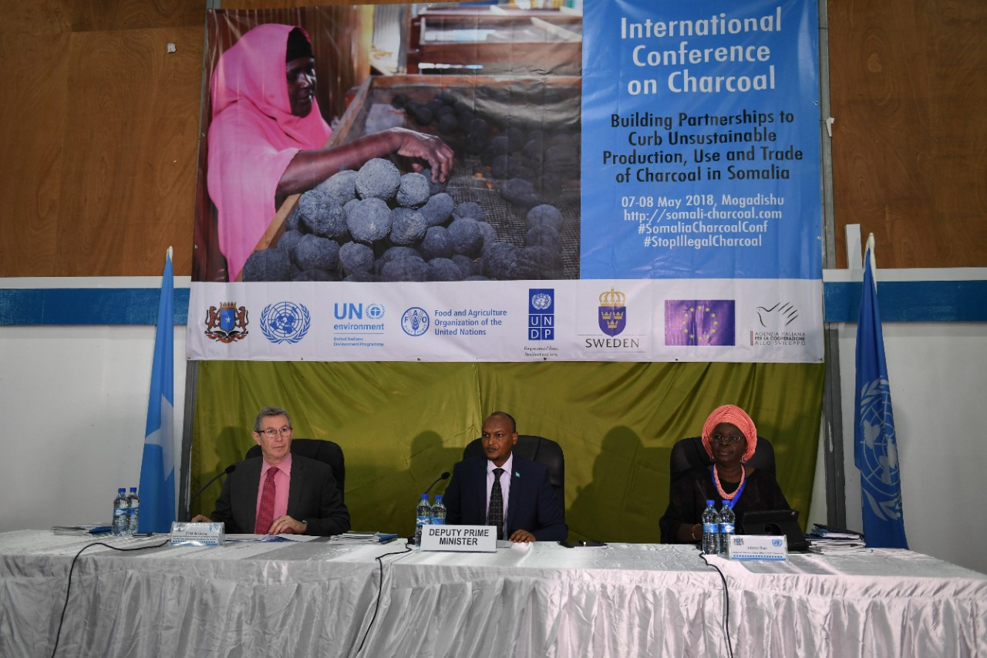
Picture 1: UNDP website - photo credit/UN photo/Ilyas Ahmed
MoLFR facilitated two coordination meetings. First meeting was held in Mogadishu on 30th May 2018 whereas second meeting (UN Post Charcoal Conference) convened in Nairobi on June 8, 2018. Both meetings emphasized enhanced information sharing and strengthening Alliance and Partnership to curb Charcoal trade.
Output 1.2: Monitoring Systems Established and Strengthened to record Charcoal Production and Movement
In May 2018, ten Jubaland Ministry of Environment and Tourism (MoET) technical staff were trained in GIS and Remote Sensing, field data collection, land degradation, natural resources conservation and management.
FAO analysed a multi-temporal dataset (2011-2017) of very-high resolution satellite images on charcoal production sites and stockpiles in Jilib, Kismayo, Badhaade, Jamaame, Afmadow and-Bu’ale Districts. Following the analysis, a technical report providing a detailed account on the trends in the number of charcoal production sites and stockpiles was finalized.
FAO in collaboration with the European Commission, Joint Research Centre (JRC) is currently testing Sentinel 2 and Landsat satellite time-series, for automated detection and monitoring of charcoal production, using loss of vegetation cover as a proxy indicator.
Field baseline surveys on charcoal production and utilization were concluded in January 2018 in Badhaade, Afmadow and Kismayo Districts. The data collected was analysed and the results presented to the Jubaland Ministry of Environment and Tourism (MoET) for feedback and endorsement.
Following the Ministry’s endorsement of the results, FAO presented the results to stakeholders during the Charcoal International Conference in Mogadishu (7-8 May 2018).
The draft baseline survey report was completed and is being editing by FAO technical staff before it can be approved and circulated to stakeholders. A few of the main findings are provided below:
- Tree cutting for fuel (firewood and charcoal) ranks second after pastoralism as a source of livelihood. This is because alternative livelihoods are limited.
- Over 60 percent of the respondents are satisfied earning income from charcoal trade. This poses a real danger that if no action is taken, communities will continue cutting down trees.
- Deforestation and soil erosion have become common causes of land degradation.
Output 1.3: Draft National and Regional Policy for Reducing Charcoal Production, Trade and Use
Peer review has been completed for the 2017 draft on National and Regional policy on Charcoal. The Ministry of Livestock, Forest and Range (MoLFR) is leading the process for the final policy. UNEP and UNDP provided te technical support for the policy formulation which is anticipated to completed by Q3 of 2018.
Output 1.4: National and International Stakeholders Mobilised to Support the Programme Objectives
Charcoal Brochures, and copies of the Government endorsed NCSA, ELD, NAP, and RRA reports distributed in the May 2018 International Charcoal Conference held in Mogadishu
The Federal Ministry of Livestock, Forest and Range (MoLFR) engaged Somali artists to promote extensive awareness raising events on the reduction of the domestic charcoal use and trade through the local media, TVs, and Radios.

Output 1.5: Improved awareness about environmental degradation due to charcoal trade
Anti-charcoal awareness campaigns were aired through local TVs, and Radios in May 2018. As part of project visibility, 4 boards and posters were erected in Hargeisa with nit-charcoal campaign info, and over185 T-shirts and Caps distributed to youths for publicity
Output 2.1: Accelerated Diffusion of Efficient Cook-stoves for Reducing Charcoal Consumption

Over 300 fuel efficient cooking stoves with 2 tons of biomass briquettes have been procured and handed over to the Federal Ministry of humanitarian Affairs and disasters and Management on 25th April 2018. This will be distributed to the most vulnerable IDPs and drought impacted communities in Mogadishu. More than 30 local manufacturers (women:5) were trained on fuel efficient making by the Somaliland Ministry of Environment and rural developments. Biomass briquettes made of organic materials, Liquefied Petroleum Gas (LPG) cylinders and fuel-efficient cooking stoves, along with development of alternative livelihoods and other alternative energy solutions, can help reduce the production and use of charcoal in Somalia.
Output 2.2: Sustainable and Efficient Production of Charcoal for Local Consumption
Not achieved. Planned in the Q3 and Q4 of 2018.
Output 2.3.: Development of Liquefied Petroleum Gas (LPG) Market and its Accelerated Diffusion to Reduce Local Charcoal Consumption Energy Plantations managed sustainably to meet the local demand of charcoal and fuel wood
Sets of 600 Liquified Petroleum Gas (LPGs) have been procured and hander over to MoLFR in April 2018. Screening of the beneficiaries finalised for 15 Mogadishu urban women retailers. Distribution 0f 300 sets of LPGs planned in July 2018 and each retailer will receive 20 sets. The Federal Government Ministry of Livestock, Forest and Range has initiated the selection process for the beneficiary on the June 30, 2018, while UNDP will participate the screening of the beneficiaries once the Ministry shares the list and distribution plan.
Output 3.1: Diversification of income and asset building for vulnerable households in order to facilitate transition to more resilient and sustainable livelihoods
FAO procured 2.5 tonnes of fodder seeds, which were delivered at the Ministry of Agriculture (MoA) Office in Kismayu. The seeds will be distributed to 400 beneficiary households in August 2018.
Assorted beekeeping equipment and tools (honey processors, wax extractors, honey harvesting kits) were procured. The supplier is expected to deliver the tools and equipment to MoA in Kismayu by the end of July 2018. The equipment and tools will be distributed to 450 households for honey production and commercialization.
In 2017, the community in Gobweyn village, Kismayo District acquired land to establish a tree nursery. A manual with environmental by-laws, guidelines for preparing information, education and communication (IEC) materials on tree nursery establishment and general conservation and management of natural resources were prepared. During the current reporting period, procurement of tree nursery tools, equipment and seeds was ongoing.

Output 4: Programme Management
One admin assistant is onboard while recruitment process for the National Task Manager has been finalised.
The 2018 AWP budget was revised and aligned with the available budget.
Other Key Achievements
- The Peer review for the Draft National and Regional Policy for charcoal reduction. The Policy Programme streamlines strategies and frameworks to minimise domestic use of charcoal and regional trade, and outlines effective monitoring and enforcement of the charcoal trade ban.
- Ban of Charcoal trade by the Somalia Government Council of Ministers in April 2018 and Enforcement of 1969 Charcoal Policy by the Somalia Attorney General office in May 2018, as well as sending of tough warnings to Somali businessmen engaged in the illegal Charcoal trade (see press release: https://www.unenvironment.org/news-and-stories/press-release/somalia-calls-international-cooperation-stop-illegal-charcoal-trade)
- Challenges (incl: Delays or Deviations) and Lessons Learnt:

Hosting of the International Charcoal Conference was often time consuming and did impact the implementation of on ground activities. The 2018 AWP was revised to accommodate hindered activities whilst focal points of the regional member states briefed during the recent Charcoal summit to accelerate the implementation of the upcoming activities.

Lessons Learnt

Strong political will and commitment deemed necessary, to fully enforce the finalised National and Regional Charcoal Policy on Charcoal. Also, the impacts of deforestation are felt across all Somalia regions, however mass of the people are still unaware of the connection of the Charcoal trade and use and its threat to natural environment and peoples’ livelihood, therefore organising more awareness raising campaigns and targeting the private sector and the beneficiaries of the Charcoal value chain seem feasible. Furthermore, decentralization of the Charcoal Programme and synergy with other Humanitarian and Development actors considered vital for tangible impacts and longer-term sustainability
Peacebuilding impact:
Not Applicable
Catalytic effects:
Not Applicable
Gender

Recruitment of six women interns is part of the 2018 LOA with the Federal Ministry of Livestock, Forest and Range. Five (5) women benefited fuel efficient cooking stoves skills facilitated by the Somaliland Environment Ministry and Rural Development. In addition, a benchmark has been set to have at least 40% women staff for the upcoming recruitments of Technical Advisors for the Regional Member States. Also, gender specific issues are highlighted in the full-scale Programme document and would be reported desegregated by gender while promoting alternative energy and livelihoods interventions.
Proportion of gender specific outputs in Joint Programme |  |  | Total no. of Joint Programme Outputs |  |  | Total no. of gender specific Outputs
 |  |  | 17 |  |  | 1
Proportion of Joint Programme staff with responsibility for gender issues |  |  | Total no. of Staff |  |  | Total no. of staff with responsibility for gender issues
 |  |  | 12 |  |  | 0 (only 3 male staff (2 TAs and admin assistant are onboard. The recruitment of 6 women interns is part of the 2018 LOA with MoLFR
Human Rights:
Not Applicable
Has the Joint Programme included a protection risk assessment in its context analysis, including on gender issues, and taken measures to mitigate these risks to ensure they are not exacerbated or new risks created? |  |  |  |  |  |  |  | Result (Yes/No)
 |  |  |  |  |  |  |  | Yes
No. of Joint Programme outputs specifically designed to address specific protection concerns. |  |  |  |  |  |  |  | Result (No.)
 |  |  |  |  |  |  |  | 10
No. of Joint Programme outputs designed to build capacity of duty bearers to fulfil their human rights obligations towards rights holders. |  |  |  |  |  |  |  | Result (No.)
 |  |  |  |  |  |  |  | 0
Other
Does the Joint Programmes have a national cost-sharing component (i.e. funds and/or other resources provided by the FGS and/or FMS (including in-kind contributions)? (if ‘Yes’, describe below). |  |  |  |  |  |  |  | Results (Yes/No)
 |  |  |  |  |  |  |  | No
Have FMS(s) been engaged in one or more of the following: design, planning, implementation, coordination and/or monitoring of the Joint Programme. |  |  |  |  |  |  |  | Results (Yes/No)
 |  |  |  |  |  |  |  | No
Describe nature of cost sharing:
Communications & Visibility:
Media Links: for the Charcoal summit
41 Media Hits – 12 international, including 6 on BBC media, 15 African regions, 8+ in Somalia

International
- Focus on Africa https://www.bbc.co.uk/programmes/w172w23gzbh7z0d (Television)
- BBC Somali http://www.bbc.com/somali/war-44031614
- BBC News hour – Interview with Peter de Clercq from 26.35 on https://www.bbc.co.uk/programmes/w172w253vspmbcq (Radio)
- BBC World Business Report Interview with Peter de Clercq: https://www.bbc.co.uk/programmes/p066gvhg (10.50 on) (Radio)
- BBC Africa News Live Updates (Blog)
- Marketplace Morning Report from BBC World Service interview with Peter de Clercq– no link (download copy available) (Radio)
- http://www.xinhuanet.com/english/2018-05/08/c_137162208.htm
- http://www.dw.com/en/somalias-illicit-charcoal-trade-threatens-security-the-environment-and-livelihoods/a-43745333
- https://africa.cgtn.com/somalia-un-meeting-focuses-on-ending-illegal-charcoal-trade/
- https://reliefweb.int/report/somalia/international-conference-illegal-charcoal-trade-opens-mogadishu
- https://africasustainableconservation.com/2018/05/17/somalias-illegal-charcoal-trade-damages-the-environment-livelihoods-and-security/
- http://www.coastweek.com/4118-Somalia-seeks-global-help-to-curb-illegal-charcoal-trade.htm

Africa Region
- http://allafrica.com/stories/201804290031.html
- http://allafrica.com/stories/201805090688.html
- http://allafrica.com/stories/201805090296.html
- https://mg.co.za/article/2018-05-13-somalias-illicit-charcoal-trade-threatens-security-the-environment-and-livelihoods
- http://www.theafricanbusinessfortune.com/regional/mogadishu-play-host-to-international-conference-on-illegal-charcoal-trade/
- https://face2faceafrica.com/article/how-this-basic-commodity-is-fuelling-conflict-and-violence-in-somalia
- https://www.the-star.co.ke/news/2018/05/07/somalia-calls-for-international-cooperation-to-stop-illegal-charcoal_c1755111
- http://africaneyereport.com/somalia-seeks-global-help-to-curb-illegal-charcoal-trade/
- https://independent.ng/somalia-seeks-global-help-to-curb-illegal-charcoal-trade/
- http://www.monitor.co.ug/News/National/UN-moves-curb-Al-shabaab-cash-points/688334-4550664-147o3ug/index.html
- https://www.tv360nigeria.com/wp-content/cache/all/somalia-charcoal-industry-damaging-environment/index.html
- http://www.environewsnigeria.com/somali-un-seek-investment-in-alternative-energy-to-halt-charcoal-trade/
- http://www.monitor.co.ug/News/National/Somalia-UN-meet-over-illegal-charcoal-sale/688334-4537300-xupimb/index.html
- https://www.journalducameroun.com/en/mogadishu-to-host-conference-on-illegal-charcoal-trade/
- https://newbusinessethiopia.com/mogadishu-set-to-host-conference-on-illegal-charcoal-trade/

Somalia
- http://goobjoog.com/english/international-conference-on-charcoal-opens-in-mogadishu/
- http://goobjoog.com/english/somalia-appeals-for-international-cooperation-to-halt-charcoal-trade/
- http://radioshabelle.com/charcoal-export-continues-as-somalia-bans-its-trade-2/
- https://hiiraan.com/news4/2018/May/157976/somalia_bans_the_export_of_charcoal.aspx
- https://www.hiiraan.com/news4/2018/May/158036/somalia_s_illicit_charcoal_trade_threatens_security_the_environment_and_livelihoods.aspx
- https://www.hiiraan.com/news4/2018/Apr/157821/somalia_to_host_conference_on_illegal_charcoal_trade.aspx
- https://heemaalnews.com/2018/05/07/somalia-charcoal-industry-damaging-environment/
- http://www.wardheernews.com/somalia-un-meet-over-illegal-charcoal-sale/
Links for Somaliland Cooking stoves manufacturers trainings on fuel efficient cooking stoves making
      - http://somalilandministryofenvironment.com/index.php/blog/150-tumaalayasha-hargaysa-oo-tobober-kor-loogu-qaadayo-aqoontoda-loo-qabtay
      - Xirfadlayaasha Hargaysa oo Tobober Kor Loogu Qaadayo Aqoontoda Loo qabtay
      - somalilandministryofenvironment.com
Links for Charcoal Awareness Raising Events:
            - https://www.youtube.com/watch?v=51zTI7ATdOI
            - https://www.youtube.com/watch?v=ndhCtrvQ-rA&t=18s
            - https://www.youtube.com/watch?v=thqlMGoETqg
            - https://www.youtube.com/watch?v=WxAWxVgwQQU
Activity Photos:
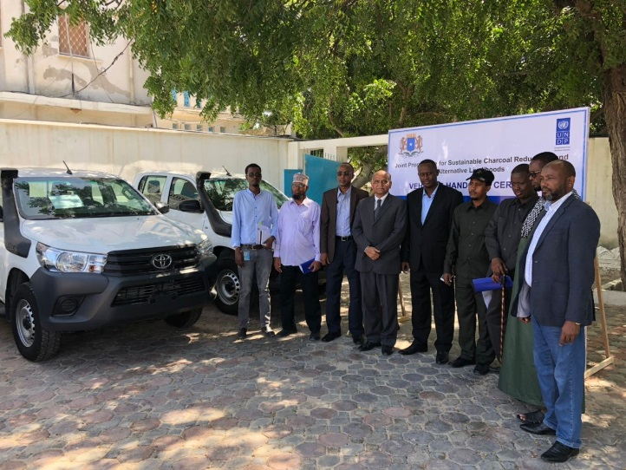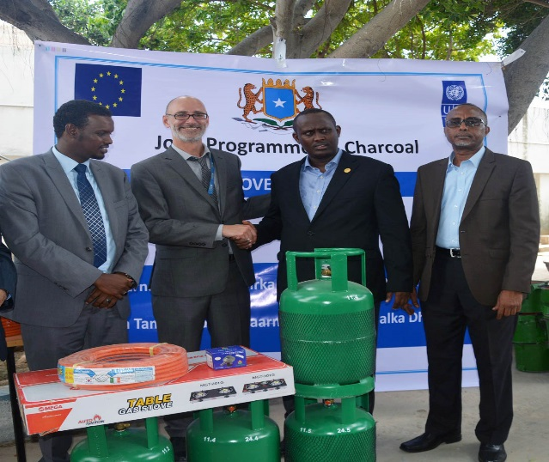
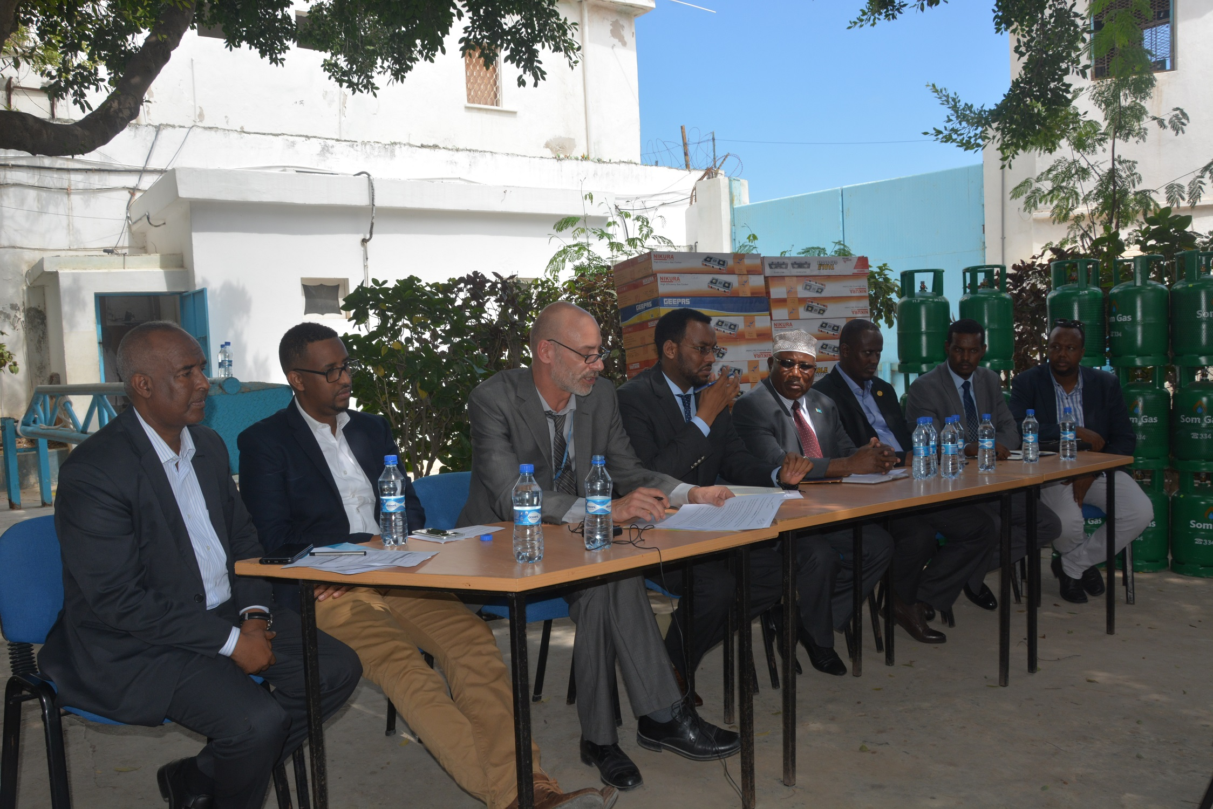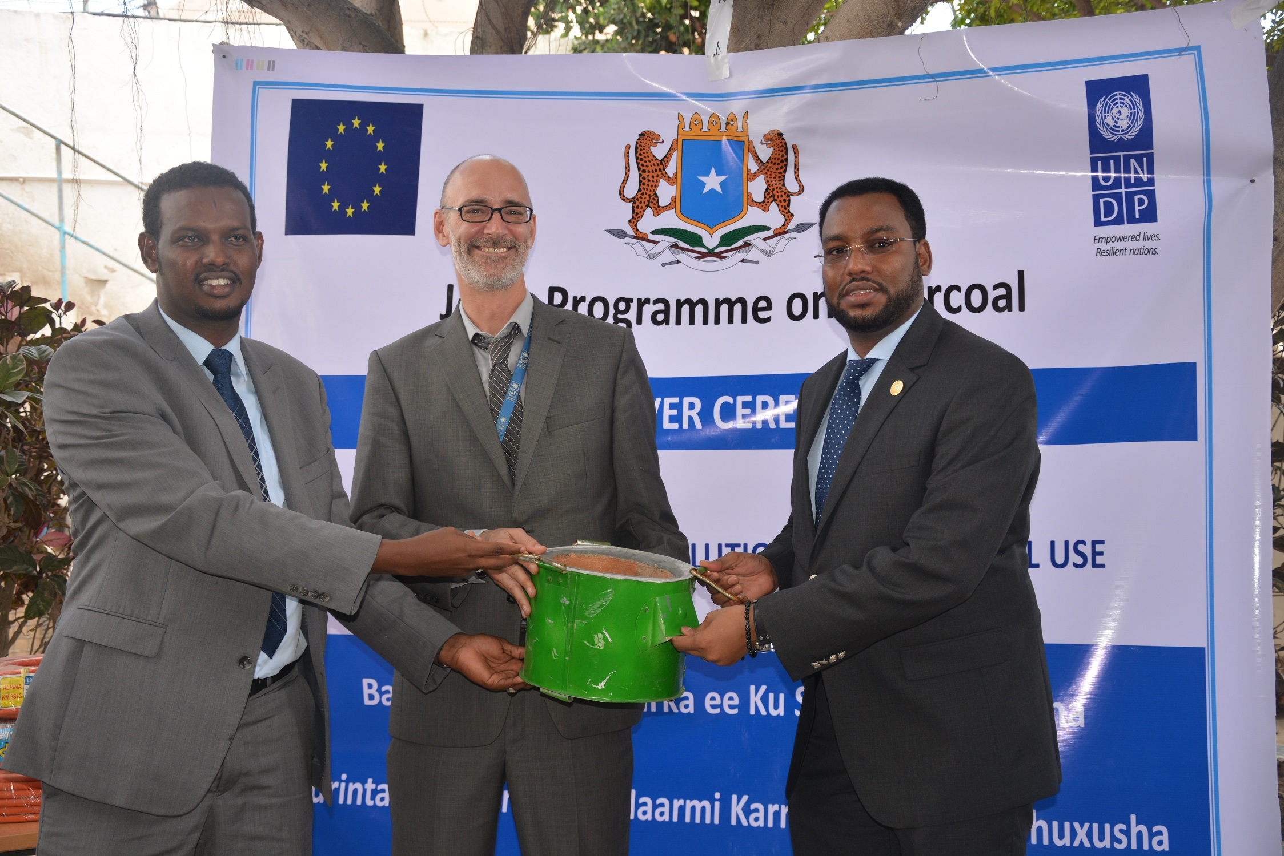

Annex 1: Handing over Vehicles to regional member states and alternative solutions to Charcoals to MoLFR
Annex. 2 Training photos for the Somaliland local Manufacturers on fuel efficient cooking stoves making and visibility billboards
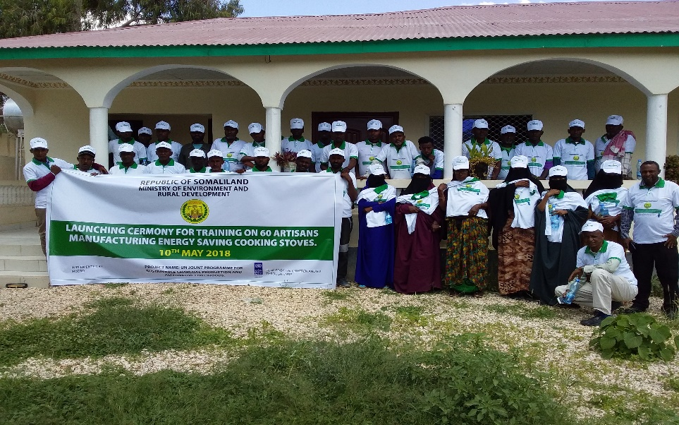 | 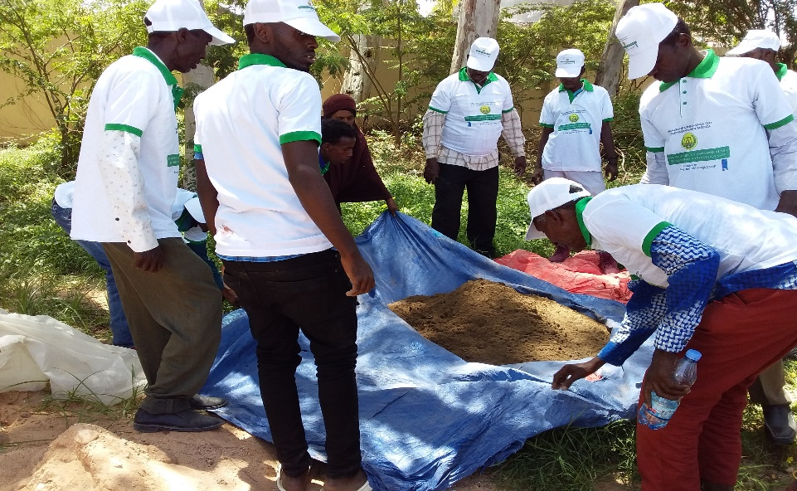
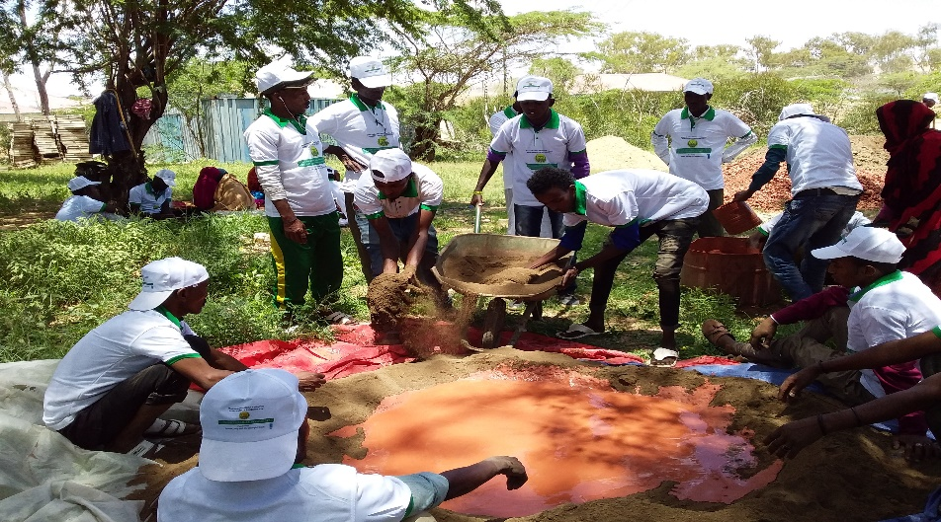 | 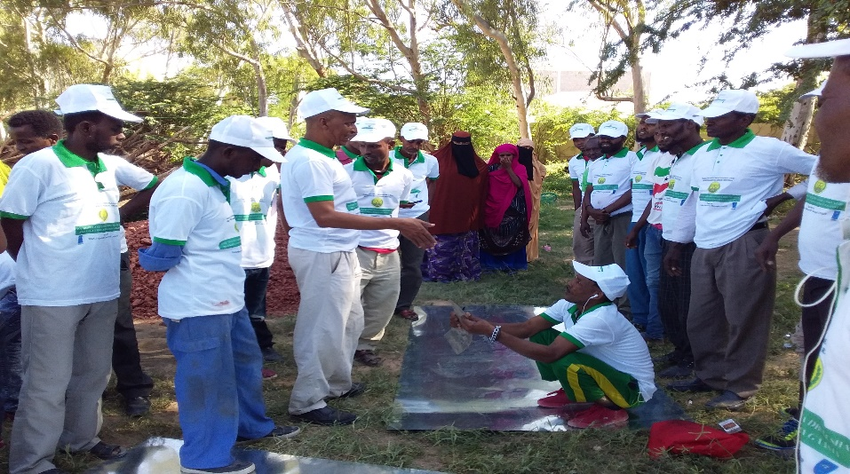
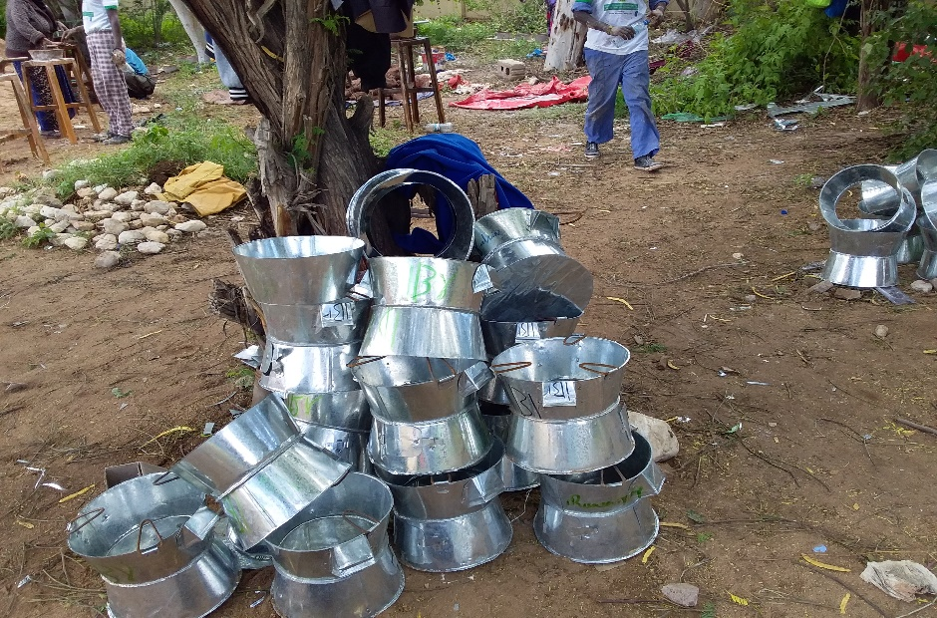 | 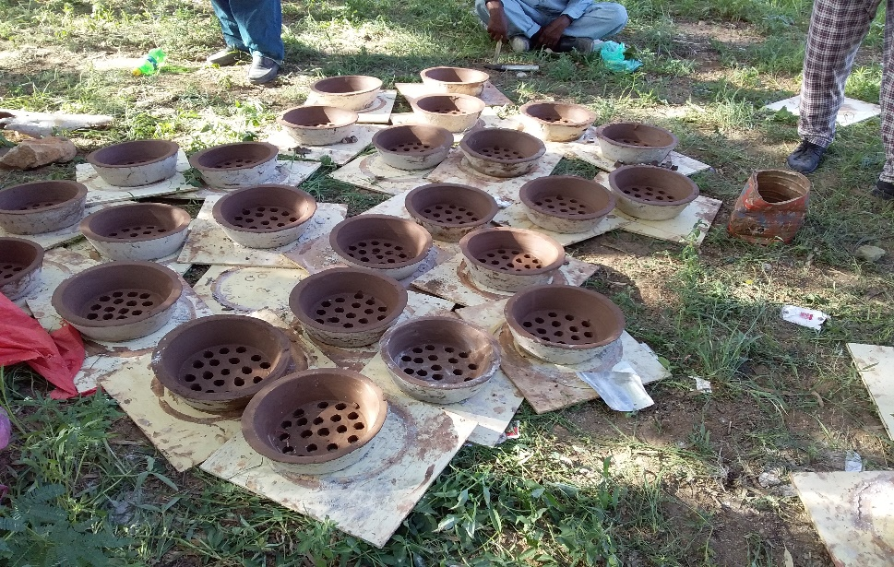
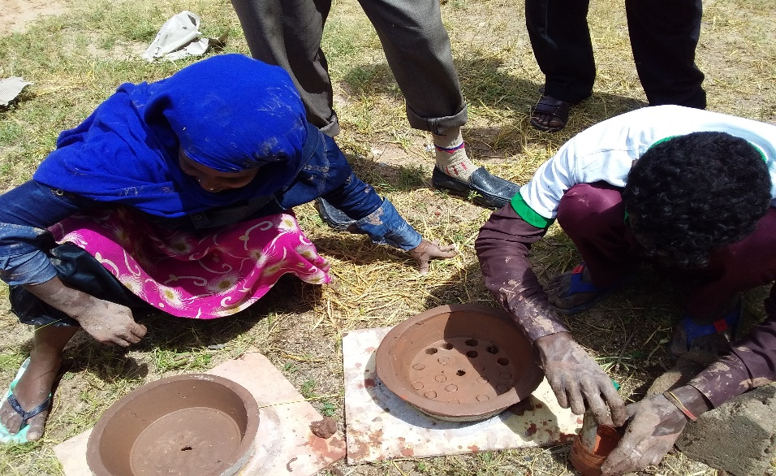 | 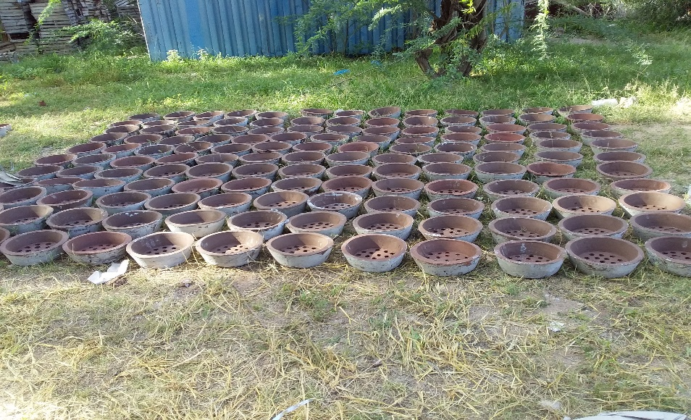
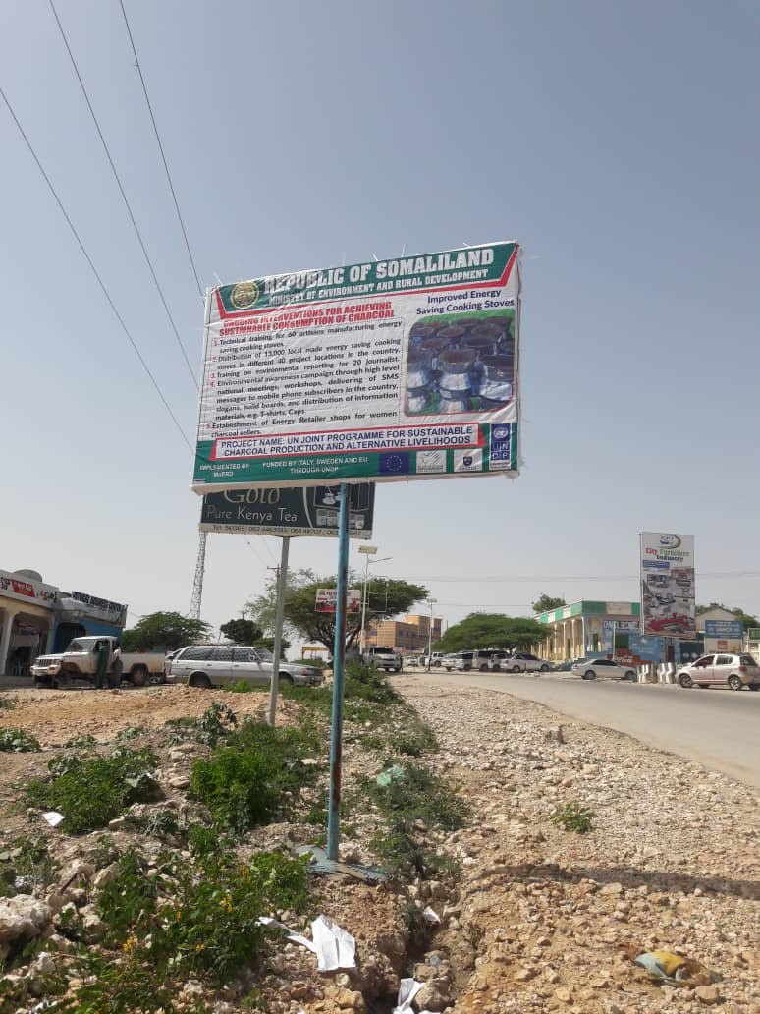 | 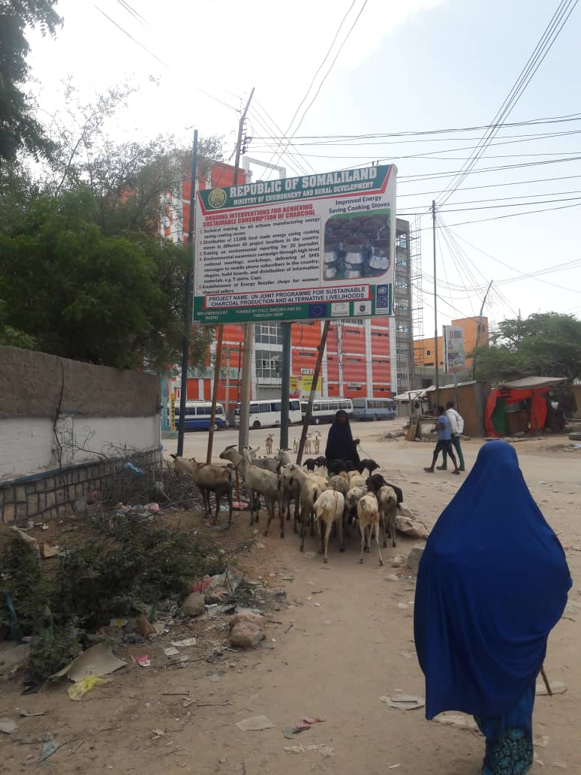

Looking ahead
      - Awareness raising campaign at nationwide level through electronic media and awareness raising workshops in the main cities and towns (Hargeisa, Garowe, Mogadishu, Kismayo, Baidoa, Jowhar and Dusamareb)
      - Procuring nested crates for project beneficiaries to package and grading vegetables for value addition
      - Distribution of Liquified Petroleum Gas (LPG) and energy efficient cooking stoves to the over 300 vulnerable IDPs in Mogadishu, and 600 sets of LPGs to 300HHs and 15 women charcoal retailers and low-income families in Somalia
      - implementing franchising model concept for retailing LPG cylinders and green stoves in major towns and IDP camps
      - Implementation of reforestation activities in Regional Member States
      - 3rd project steering committee meeting
      - Establishment of national committee with secretariat support to develop the national and regional policy
      - Somalia Partnership Forum in Brussels
      - Setting up of Energy Retailer shops for 200 women charcoal sellers/retailers from the 6 targeted Somaliland regions and supporting them on its very distribution.
      - Provision of fuel efficient cooking stoves to 8000 vulnerable HHs (IDP:4000HH, & Host community: 4000
      - Training workshop for the local media on Environmental reporting HHs) of Somaliland project targeted regions/locations
      - Procuring nested crates for project beneficiaries to package and grading vegetables for value addition

ANNEX 1. RISK MANAGEMENT
This section can be used to update or use the risk logs developed during the project development stage and provide any mitigation measures being undertaken by the project. (State whether the risk is from the ProDoc or is new, whether the Joint Programme was exposed during the reporting period and what specific mitigation measures were applied.

Type of Risk | Description of Risk | Mitigating Measures
Financial | Lack of funding from the donors may cause substantial risk of not achieving the objectives of full joint Programme. | Senior leadership of UN System and Federal Government were involved in raising funding to implement the Programme. The currently available funding is USD 6.6 Million i.e. 29% of the full Programme budget of USD 23.6 million. Also, further resource mobilisation has been approved by the Programme Steering Committee– including African Development Bank – activities on charcoal substitution. MOLFR to get a letter from Ministry of Finance to allocate AFDB funds through Charcoal Programme, and Senior Programme Management to follow up this with AFDB on further requirements
Social and Environmental Screening Risks | Duty-bearers do not have the capacity to meet their obligations in the Project | The Programme is developing government capacity to formulate laws to curb charcoal trade, sensitize the custom, and law enforcement authorities about the issue and provide operational funds for the purpose. Further, the Programme may recommend Government to call the support of Security Council to enforce illegal trade, if it does not stop. In addition, letters of agreements have been signed with FGS MoLFR and Somaliland MoERD to implement and coordinate the 2018 planned activities. Furthermore, the Programme supported the hosting of an Internal Charcoal Summit in Mogadishu to curb Charcoal trade and would similarly support the implementation of the roadmaps and upcoming partnership forum in Brussels
Social and Environmental Screening Risks | The Project involve harvesting of natural forests, plantation development, or reforestation | The project is embedding design to address the existing gap on environmental un-sustainability and promote the use of other source of energy other than charcoal i.e. solar, wind and biogas. For longer term sustainability capacity building on environmental protection and conservation will be enhanced at national and community level. Also, it’s the aim of the project to support the charcoal traders with alternative source of livelihoods and empower them as well to remain in the very business for a longer time through provision of small business grants. The Project has also reforestation and plantation activities in the charcoal depleted forest to regenerate grazing land fertility and minimize further land degradation. Furthermore, USD 0.5Million of the available budget has been approved by the second Programme Steering Committee to cover the energy needs of the Vulnerable IDP communities in Somalia. The funds will support the procurement and distribution of Liquified Petroleum Gas (LPG) and Energy Efficient Cooking Stoves.
Social and Environmental Screening Risks | Project would have adverse impacts on gender equality and/or the situation of women and girls | Women are the primary retailers of Charcoal and are likely to suffer impact in income as a result of Charcoal production. Understanding this need, project is prioritizing initiatives and opportunities for women, including access to start-up funds for alternative resources, engagement with women and CSOs to ensure women’s needs and rights are met with. Over 8300 women lead IDPs/HHs would receive fuel efficient cooking stoves with biomass briquettes, 100 local manufacturers will be trained on fuel efficient cooking stoves making, 250 women retailers would be established and supported with startup grants for business models/600 LPG sets

ANNEX 2. MONITORING AND OVERSIGHT ACTIVITIES:

Monitoring Activity | Date | Description & Comments | Key Findings / Recommendations
Oversight visit to the Office of the Federal Ministry of Livestock, Forest and Range (MoLFR) | 15/04/18 | Monitoring of the recruitment process for the Technical Advisors at MoLFR Mogadishu | - MoLFR advertised current position in Local media. i.e. TVs, Radios, and local newspapers.  - UNDP was informed in advance by the Ministry to participate the selection process  - The Resilient and Climate Change, M & E Officer represented the Portfolio to oversee the recruitment process and selection of the potential candidates  - Applications were received on two areas of expertise (Capacity building Advisor, and Forestry Technical Advisor)  - A total of 9 applicants (0 women) were interviewed both in written and oral sessions  - Two potential candidates (Mr. Hassan Haji, and Mr. Said Jumale) were recommended to lead the capacity building and Forestry units of the MoLFR  - The current recruitment was much transparent and the Ministry to follow the same course for the upcoming recruitment for the region member states (Galmudug, Hir-Shabelle, South west and Jubaland)
Stakeholders Coordination Meeting | 30/05/18 | Stakeholders Coordination meeting for the Federal Ministry of Livestock, Forest and Range (MoLFR) and Line Ministries of the four regional member States | - The meeting was held at MoLFR Office in Mogadishu  - The objective was to enhance the coordination and information sharing strategies for the implementation of the Joint Programme on Charcoal  - Eleven key officials attended the meeting  Agreed actions:  - To have at least two such coordination meetings monthly  - To present the outcomes to the Project Board for consideration and action  - Each regional member state to nominate at least two focal point persons to form the National Charcoal Programme task committee  - The National Task Committee (NTC)will coordinate, Harmonize the information sharing and play the oversight role for the implementation of the Joint Programme on Charcoal  - The NTC will also handle emerging issues and complaints regarding the implementation of the Full-scale Programme

ANNEX 3. TRAINING DATA <list here details of training activities undertaken during the reporting period; should not exceed one page>
# | Target Group |  | Dates | # of participants |  |  | Title of the training | Location of training | Training provider
# | Ministry. District or UN staff | Others
 |  |  |  | M | F | Total | Title of the training | Location of training | Training provider
 |  | Local manufacturers | 10/04/18-28/05/18 | 25 | 5 | 30 | Trainings for the local manufacturers on fuel efficient cooking stoves making | Hargeisa | Somaliland MoERD
 | Jubaland  Ministry of Environment and Tourism |  | My 6 -21-2018 | 9 | 1 | 10 | GIS & Remote Sensing, Field data collection, land degradation, natural resources conservation and management | Kismayo | FAO SWALIM
Totals: |  |  |  | 34 | 6 | 40

Uncertified expenditures. Certified annual expenditures can be found in the Annual Financial Report of MPTF Office (http://mptf.undp.org/factsheet/fund/4SO00 )
Fill in only the numbers or yes/no; no explanations to be given here.
Gender Specific Outputs are those that are specifically designed to directly and explicitly contribute to the promotion of Gender Equality and Women’s Empowerment.
Staff members are those contracted to undertaken work for the Joint Programme including full time staff, consultants, advisors, interns, etc. Staff members with responsibility for gender issues are those who have gender related activities included in their Terms of Reference.
Environmental; Financial; Operational; Organizational; Political; Regulatory; Security; Strategic; Other.

